EXPERIMENT- 3

AIM:-
Write a program to find FIRST & FOLLOW Symbols for the given grammar.

THEORY:-
Syntax analysis is the second phase of a compiler and comes after the Lexical analysis. It is the process of analyzing a string of symbols to determine whether it complies with the rules of formal grammar. It is a necessary step in compiling programs written in programming languages. To create computer-executable object programs, the source program must be checked for the correctness of the lexicon, syntax, and semantics.

It is also known as the Parse Tree or Syntax Tree. The Parse Tree is developed with the help of pre-defined grammar of the language. The syntax analyser checks whether a given program fulfills the rules implied by a context-free grammar. If it satisfies, the parser then creates the parse tree of that program or, it will display error messages.

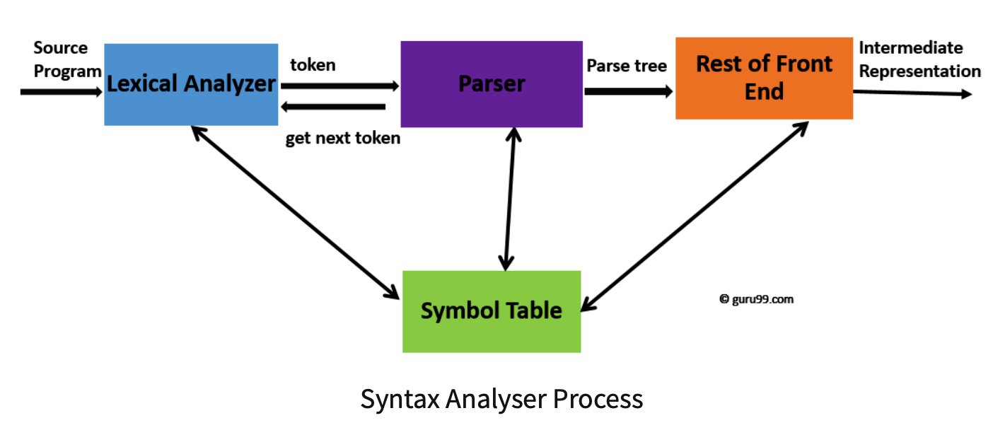

Key Functions of Syntax Analyzer:
- Tokenization: The first step involves breaking down the source code into tokens. Tokens are the smallest units of the source code, such as keywords, identifiers, operators, and literals.

- Syntax Checking: The syntax analyzer checks the arrangement of tokens to verify whether it conforms to the specified grammar rules of the programming language. If the code violates any syntax rules, the syntax analyzer generates error messages indicating the nature and location of the errors.
- Parse Tree Generation: Upon successful syntactic analysis, the syntax analyzer constructs a hierarchical structure known as a parse tree or syntax tree. This tree represents the grammatical structure of the source code, with each node corresponding to a syntactic construct.
- Error Handling: If errors are detected during the syntax analysis phase, appropriate error recovery mechanisms may be applied to continue analyzing the rest of the code. Error messages are generated to help programmers identify and correct the issues.

Significance of Syntax Analyzer:
The syntax analyzer, as a crucial phase in the compilation process, holds significant importance in the development of software. Its role goes beyond merely checking for syntactic correctness; it plays a pivotal role in ensuring the overall integrity and quality of the compiled code.
- Error Detection and Reporting: One of the primary functions of the syntax analyzer is to detect errors in the source code. Syntax errors can range from simple typos to complex structural issues. By identifying and reporting these errors early in the compilation process, the syntax analyzer helps programmers correct mistakes promptly. Clear and precise error messages are generated, guiding developers to the specific location and nature of the errors

- Enforcement of Syntax Rules: The syntax analyzer enforces the syntactic rules defined by the programming language's grammar. This ensures that the source code adheres to a standardized and consistent structure. By maintaining consistency in the code, developers are encouraged to write clean, readable, and maintainable programs.

- Structural Analysis: Beyond error checking, the syntax analyzer performs a comprehensive structural analysis of the source code. It constructs a hierarchical representation of the code, often in the form of a parse tree. This structural analysis provides insights into the relationships between different components of the code, aiding in subsequent compilation phases.

Role of Context Free Grammar(CFG) in Syntax analysis-
Syntax analysis uses context-free grammar to define the syntax of the programming language. CFG is a formal language used to describe the structure of programming languages. It serves as the basis for parsers, tools that analyze source code grammatically and also contribute to error detection by flagging syntax errors when a sequence of tokens violates the grammar rules. CFGs are employed in tool development, used as the foundation for parser generators that automate the creation of parsers based on grammar rules.

Parser-
Parser is a compiler that is used to break the data into smaller elements coming from the lexical analysis phase. A parser takes input in the form of a sequence of tokens and produces output in the form of a parse tree. It examines text made up of a series of tokens to ascertain its grammatical structure in relation to grammar.
Parsing is of two types: top down parsing and bottom up parsing.
1. Top-Down Parsing:-
The parser builds the parse tree starting with the start symbol and then tries to transform the start symbol into the input. Top-down parsing analyzes the input and builds the parse tree from the root to the leaf. To create a parse tree, the leftmost derivation is used.
Recursive descent parsing and LL parsing are two examples of top-down parsing algorithms.

LL(1) PARSER-
LL parser in compiler design is a predictive parser implementation that uses an implicit stack and parsing table to determine the production that should be used for a non-terminal.
If an LL parser uses k look-ahead tokens to parse a sentence, it is called an LL(k) parser. Because LL grammars, especially LL(1) grammars, are simple to build as parsers, many computer languages are created to be LL(1). The 1 denotes using a single input symbol for forward-looking decisions during each phase of the parsing process.
The following are the prime requirements for the LL(1) parser:
- The grammar must have no left factoring and no left recursion.
- FIRST() & FOLLOW()
- Parsing Table
- Stack Implementation
- Parse Tree

2. Bottom-up Parsing:-
This parser compresses the non-terminals where it starts and moves backward to the starting symbol of the parse tree using grammar productions to draw the input string's parse tree. Parsing starts from the leaf node of the parse tree to the start symbol of the parse tree in a bottom-up manner using Right Most Derivation..
Shift-Reduce Parsing, Operator Precedence Parsing, Table Driven LR Parsing are three examples of bottom-up parsing algorithms.
Shift-Reduce PARSER-
Shift reduce parsing is a process to reduce a string to its grammar start symbol. It uses a stack to hold the grammar and an input tape to hold the string. Shift reduce parsing performs the two actions: shift and reduce. The current symbol in the input string is pushed to a stack at the shift action. At each reduction, the symbols will be replaced by the non-terminals. The non-terminal is the left side of the output, and the symbol is the right side of the production.
There are two main categories in shift-reduce parsing as follows:
- Operator-Precedence Parsing
- LR-Parser

Difference between Top-Down and Bottom-Up Parsers:
● Top-Down parsers start with the start symbol and expand it to match the input string, while bottom-up parsers start with the input string and reduce it to the start symbol.
● Top-Down parsers are generally easier to implement manually but might not handle as wide a range of grammars as bottom-up parsers.
Conditions for LL(1) Grammar:
An LL(1) grammar is suitable for top-down parsing. The conditions for an LL(1) grammar are as follows:
● No left recursion: A grammar should not have direct or indirect left recursion.
● No common prefixes in the FIRST sets of alternative productions.
● No ε-productions (productions that derive the empty string) in the FIRST set of non-terminals.

Rules for Deriving FIRST and FOLLOW Symbols:
● FIRST(X): The set of terminals that begin the strings derivable from symbol X.
● If X is a terminal, then FIRST(X) = {X}.
● If X is a non-terminal, then FIRST(X) includes the first terminal in each of its alternative productions.
● If X can derive ε (empty string), then FIRST(X) includes ε.

● FOLLOW(X): The set of terminals that can appear immediately to the right of X in some sentential form.
● FOLLOW(Start symbol) = {$} (where $ is the end-of-input marker).
● If there is a production A → αBβ, then everything in FIRST(β) (excluding ε) is in FOLLOW(B).
● If there is a production A → αB or A → αBβ where FIRST(β) contains ε, then everything in FOLLOW(A) is in FOLLOW(B).

Implementation -

import sys

def compute_first(string):
first_set = set()

if string in non_terminals:
alternatives = productions_dict[string]
for alternative in alternatives:
first_set |= compute_first(alternative)

elif string in terminals:
first_set.add(string)

elif string == '' or string == '@':
first_set.add('@')

else:
first_set |= compute_first(string[0])
if '@' in first_set:
i = 1
while '@' in first_set:
first_set -= {'@'}
if string[i:] in terminals:
first_set.add(string[i:])
break
elif string[i:] == '':
first_set.add('@')
break
first_set |= compute_first(string[i:])
first_set -= {'@'}
i += 1

return first_set

def compute_follow(nt):
follow_set = set()
if nt == starting_symbol:
follow_set.add('$')

for non_term, productions in productions_dict.items():
for prod in productions:
for i, char in enumerate(prod):
if char == nt:
if i < len(prod) - 1:
follow_set |= compute_first(prod[i + 1:])
if '@' in follow_set:
follow_set -= {'@'}
follow_set |= compute_follow(non_term)
else:
if non_term != nt:
follow_set |= compute_follow(non_term)

return follow_set

no_of_terminals = int(input("Enter the number of terminals: "))
terminals = [input(f"Enter terminal {i + 1}: ") for i in range(no_of_terminals)]

no_of_non_terminals = int(input("Enter the number of non-terminals: "))
non_terminals = [input(f"Enter non-terminal {i + 1}: ") for i in range(no_of_non_terminals)]

starting_symbol = input("Enter the starting symbol: ")

no_of_productions = int(input("Enter the number of productions: "))
productions = [input(f"Enter production {i + 1}: ") for i in range(no_of_productions)]

productions_dict = {nt: [] for nt in non_terminals}
for prod in productions:
non_term, production = prod.split("->")
alternatives = production.split("/")
productions_dict[non_term].extend(alternatives)

FIRST = {nt: set() for nt in non_terminals}
FOLLOW = {nt: set() for nt in non_terminals}

for nt in non_terminals:
FIRST[nt] |= compute_first(nt)

FOLLOW[starting_symbol] |= {'$'}
for nt in non_terminals:
FOLLOW[nt] |= compute_follow(nt)

print("{: ^20}{: ^20}{: ^20}".format('Non Terminals', 'First', 'Follow'))
for nt in non_terminals:
print("{: ^20}{: ^20}{: ^20}".format(nt, str(FIRST[nt]), str(FOLLOW[nt])))

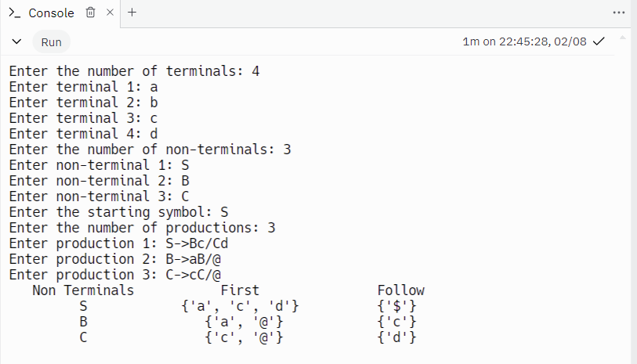

CONCLUSION:-

In summary, we've learned how syntax analyzers work and the differences between top-down and bottom-up parsers. We've also grasped the rules for finding FIRST and FOLLOW symbols from a given grammar, and even built a program to do just that. This has given us a better understanding of how programming languages are structured and analyzed. By putting theory into practice, we've improved our skills in programming language design. This knowledge will help us in creating better compilers and understanding languages more deeply in the future.

